Table of Contents

CHAPTER 1: INSTALLING ORACLE DATABASE 12C 2

Theory 2

AIM 4

Lab Exercise 1: INSTALLING ORACLE DATABASE 12C 5

1. Download and Prepare for Oracle Database 12c 6

2. Installing Oracle Database 12c 11

SUMMARY 44

REFERENCES 45

INDEX 46

# CHAPTER 1: INSTALLING ORACLE DATABASE 12C

## Theory

PL/SQL stands for **Procedural Language extensions of SQL**. It is important to know that PL/SQL is **not** SQL; instead, it is an extension of SQL. In addition, PL/SQL is a procedural language running inside Oracle Database server. This means it is not standard language and, in specific, it has nothing to do with other databases but Oracle Database. Other database products, such as Microsoft SQL Server, have their own procedural languages. For example, Microsoft SQL Server's procedural language is T-SQL.

The value of PL/SQL lies on its role in building the logic and control. Consider, for example, a point of sale system where you have two tables: ITEMS and STORE, as shown below:

-1

-2

-1

|  |  |  |  |  |
| --- | --- | --- | --- | --- |
| ITEMS | |  | STORE | |
| itm1 | 2 | 110 | itm1 |
| itm2 | 1 | 95 | itm2 |
| itm1 | 1 |  |  |

In this example, the transaction done on ITEMS table should be reflected on the corresponding items in STORE table; so, when 2 pieces of *itm1* has been purchased (as shown in ITMS first record), the balance of itm1, 110, should be decreased by 2. Thus, the new balance should be: 110-2=108. In other words, when new records have been inserted in ITEMS table, a modification has to be done on STORE to add/subtract the corresponding amount from the item. Obviously, the structured query language (SQL) alone cannot satisfy this business logic. What we need here is some code that should run whenever a transaction has been done on ITEMS table, namely a TRIGGER. The code should read the balance of the item in question from STORE table, normally done by SELECT statement. The new balance then should be calculated in an arithmetic operation: VAR := balance - item1.amount. Finally, new balance (VAR) should be stored permanently in STORE table using UPDATE table.

From the previous example, the reader can easily recognize that PL/SQL is closely related to SQL. PL/SQL developer extensively uses SQL statements to retrieve relevant data stored in tables. To this sake, Oracle makes it so easy to call and execute SQL statements in PL/SQL blocks. In comparison, external languages such as Java and C# lack this simplicity. To that sake also, PL/SQL block is parsed and executed inside Oracle Database; in specific, in PL/SQL engine.

SQL

External Languages

Multiple SQL Statement

PL/SQL Block

SQL

**Oracle Database**

**PL/SQL Engine**

Parse and execute PL/SQL block

**SQL Engine**

Parse and execute SQL statements

Again, external languages open cursers to execute SQL statements multiple times. Even external languages send SQL statements to SQL Engine directly, they cost much more than PL/SQL because PL/SQL block is sent once over network. Using PL/SQL block, the networking overhead is just O(1), while using external languages is O(n) where n: the number SQL statements.

Another advantage to use PL/SQL is the business layer centrality. When a business layer developed as PL/SQL packages, stored procedures, stored functions, triggers, and object types, this enhances code centrality. Thus, avoiding code repetition, code redundancy, and conflicting logic appear usually when re-write the same code in many times in different layers.

In this section, you will download and install Oracle Database 12c which is a pre-required step before using PL/SQL block.

## AIM

The AIM of the following exercise is to demonstrate how to download Oracle Database 12c.

The steps involved will include:

* Download and Prepare for Oracle Database 12c.
* Installing Oracle Database 12c.

Estimated Completion Time:

25 minutes

# Lab Exercise 1: INSTALLING ORACLE DATABASE 12C

|  |
| --- |
|  |

## Download and Prepare for Oracle Database 12c

**Step 1:** Download Oracle 12c R1 for Linux x86-64 from the following URL "**http://www.oracle.com/technetwork/database/enterprise-edition/downloads/index.html**".

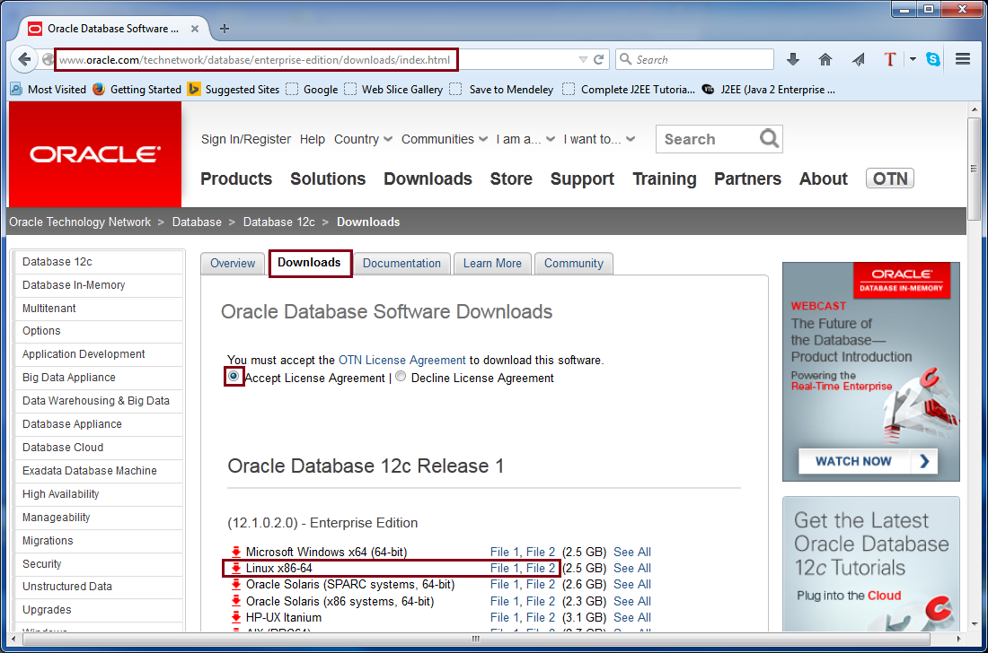

**Step 2:** Login if you have an account, or create new one if you do not have. 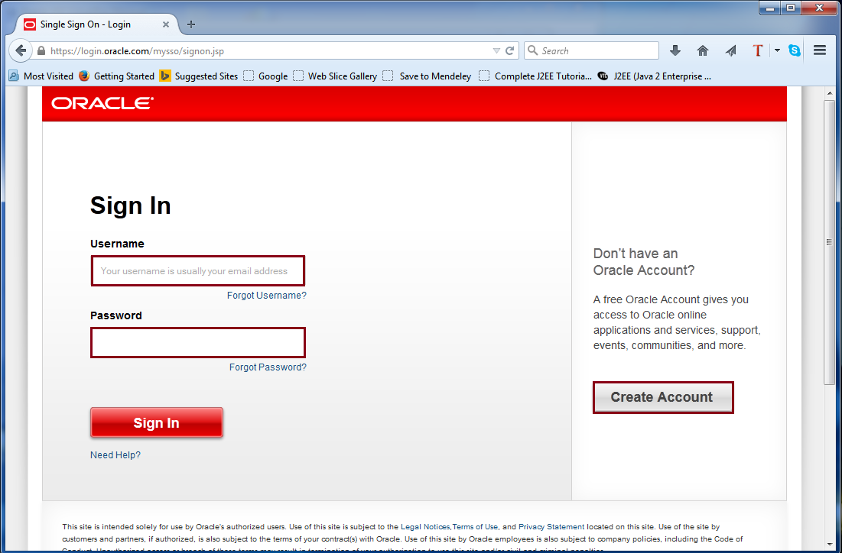

**Step 3:** Download the two parts and save them in the following folder: **"/home/oracle/Downloads/DB12cR1**". Make sure to extract both file in "**database**" folder.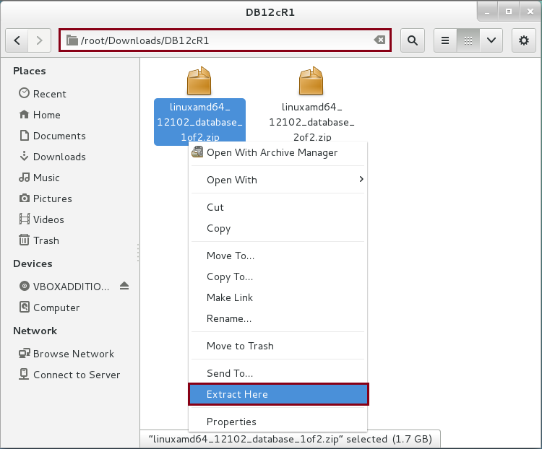

**Step 4:** Login as a "**root**" and create the following local operating system groups and users which are required if you to install Oracle Database:

|  |  |
| --- | --- |
| Command | Description |
| groupadd oinstall | Create group oinstall |
| groupadd dba | Create group dba |
| useradd -g oinstall -G dba oracle | Create 'oracle' user and grant 'oinstall' and 'dba' group to the user. |
| id oracle | Be sure 'oracle' user has his right privileges. |
| passwd oracle | Change oracle password |
| New password: | Type "oracle321" as user password. |
| Retype new password: | Type "oracle321" again. |

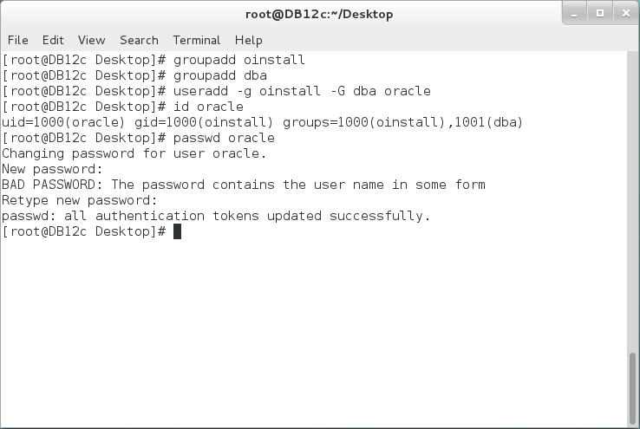

**Step 5:** Open the Terminal and execute the following commands to edit system parameter values:

|  |  |
| --- | --- |
| Command | Description |
| vi /etc/sysctl.conf | Edit system parameters. |

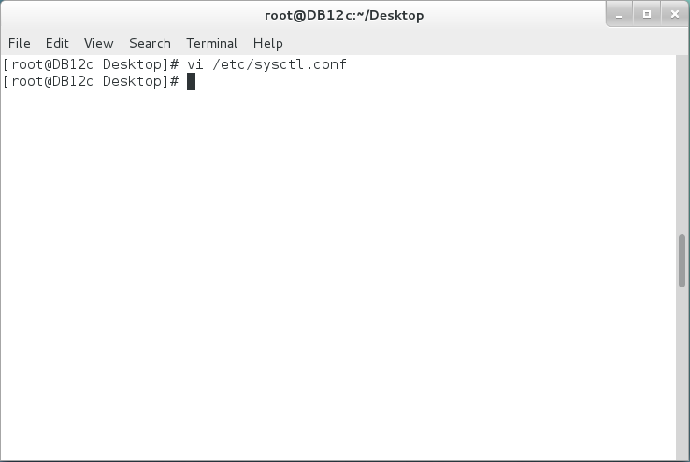

**Step 6:** Add the parameters' values as shown below, don't forget to save changes by pressing **ESC** and typing **":wq**" :

|  |
| --- |
| Parameters |
| fs.aio-max-nr = 1048576  fs.file-max = 6815744  kernel.shmall = 2097152  kernel.shmmax = 536870912  kernel.shmmni = 4096  kernel.sem = 250 32000 100 128  net.ipv4.ip_local_port_range = 9000 65500  net.core.rmem_default = 262144  net.core.rmem_max = 4194304  net.core.wmem_default = 262144  net.core.wmem_max = 1048586 |

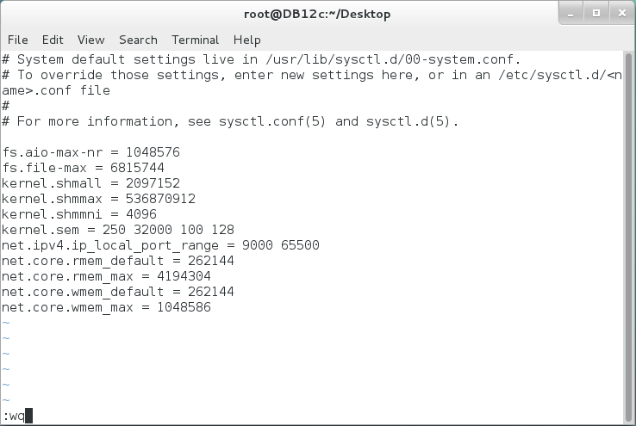

**Step 7:** In my lab, Oracle Database will be installed on Oracle Linux 7. Most of required packages are installed already. Open the Terminal and install the following packages using yum command. If you have difficulties in installing any of the specified packages, please ask your trainer to help you.

|  |
| --- |
| **Install Required Packages.** |
| yum install libaio-devel.i686 |
| yum install ksh |
| yum install libaio-devel-0.3.109 |

**Step 8: Reboot** your system, login as "**oracle**" user and check if the kernel parameters have been set permanently. Open the Terminal and execute the following commands:

|  |  |
| --- | --- |
| Command | Description |
| su | login as 'root' user |
| password: | Enter **'oracle321'** as a 'root' password. |
| /sbin/sysctl -a | grep sem |  |
| /sbin/sysctl -a | grep shm |  |
| /sbin/sysctl -a | grep file-max |  |
| /sbin/sysctl -a | grep ip_local_port_range |  |
| /sbin/sysctl -a | grep rmem_default |  |
| /sbin/sysctl -a | grep rmem_max |  |
| /sbin/sysctl -a | grep wmem_default |  |
| /sbin/sysctl -a | grep wmem_max |  |

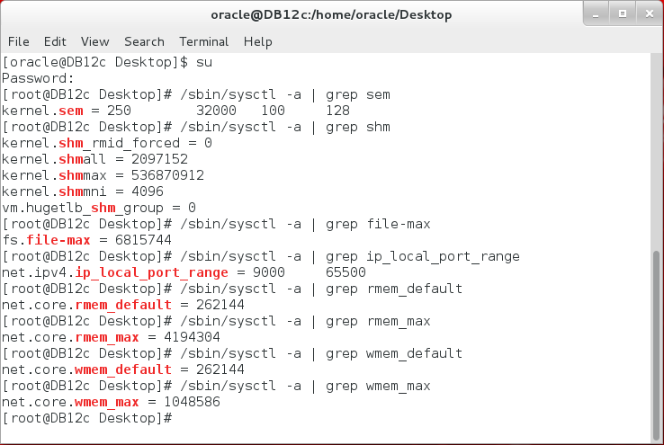

## Installing Oracle Database 12c

**Step 1:** Before installing Oracle database, make sure you CUT and PASTE DB12cR1 folder in "**/home/oracle/Downloads/DB12cR1/database/**" directory with appropriate privileges to 'oracle' user. Open the Terminal and execute the following commands:

|  |  |
| --- | --- |
| Command | Description |
| cd /home/oracle/Downloads/DB12cR1/database/ | Change directory to DB12cR1/database folder |
| ll /home/oracle/Downloads/DB12cR1/database/ | Be sure 'oracle' user has appropriate privileges on the folder. |
| ./runInstaller | Run Oracle Database 12c installer |

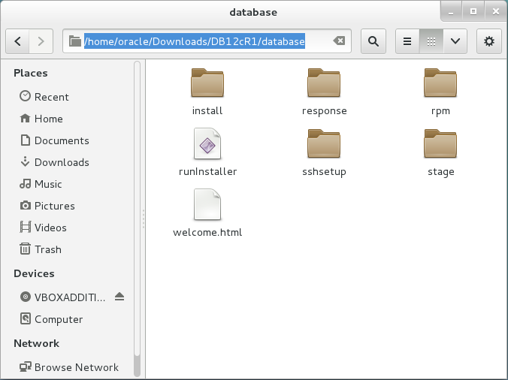

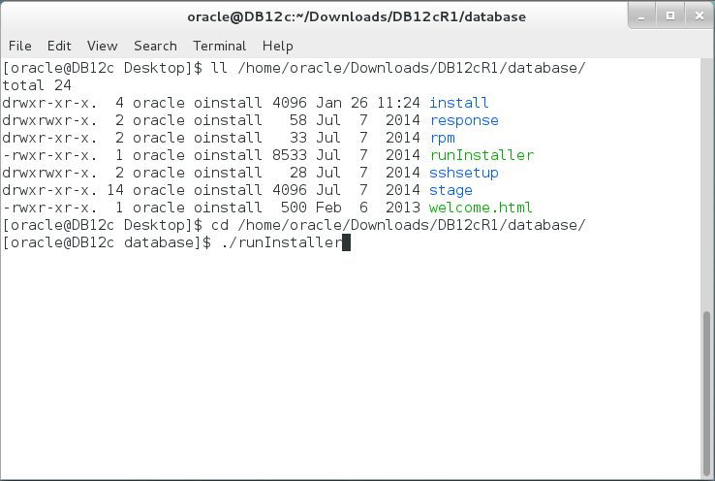

**Step 2:** Uncheck security update option and click on "**Next**" button. 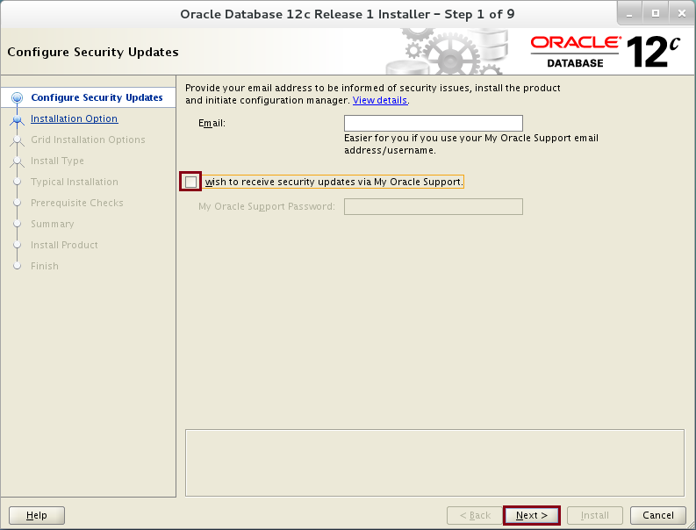

**Step 3:** Click on "**Yes**" button.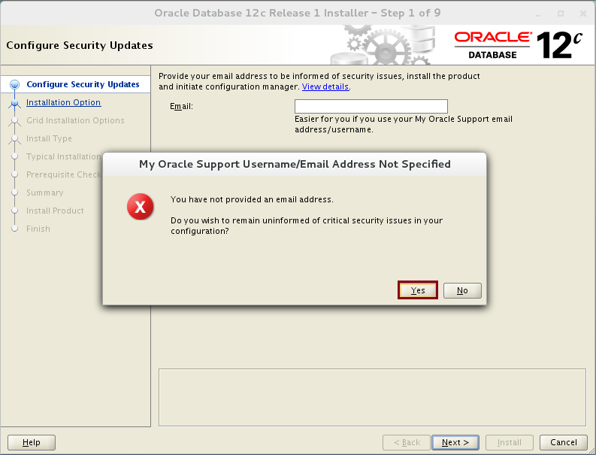

**Step 4:** Select "**Create and configure a database**" option and click on "**Next**" button.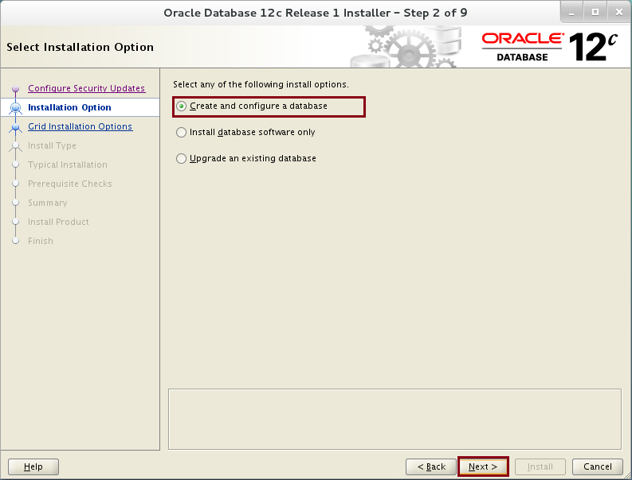

**Step 5:** Select "**Server Class**" option and click on "**Next**" button.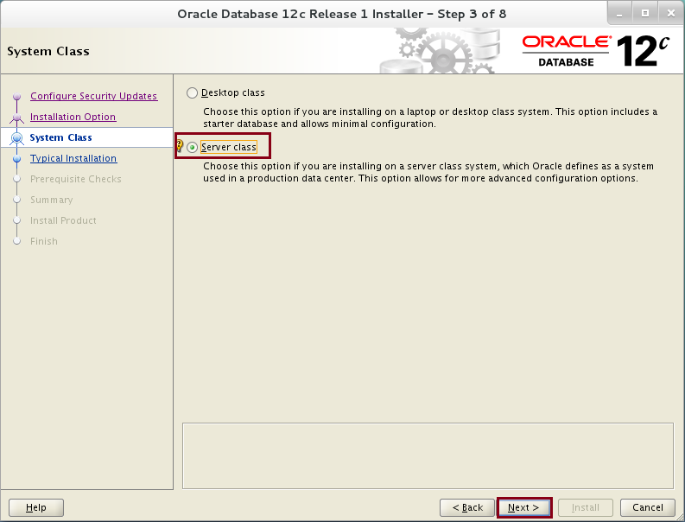

**Step 6:** Click on "**Next**" button.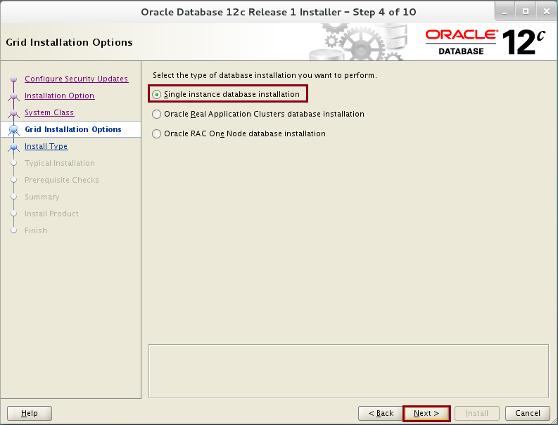

**Step 7:** Select "**Advanced install**" option and click on "**Next**" button.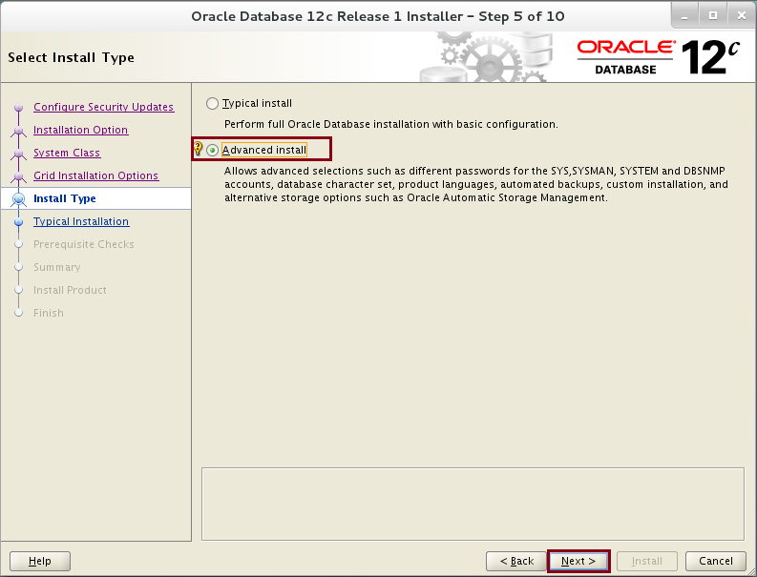

**Step 8:** Click on "**Next**" button.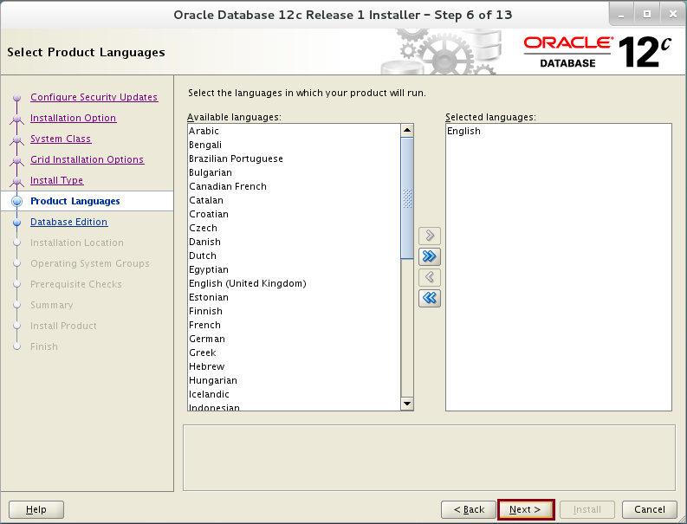

**Step 9:** Select "**Enterprise Edition**" and click on "**Next**" button.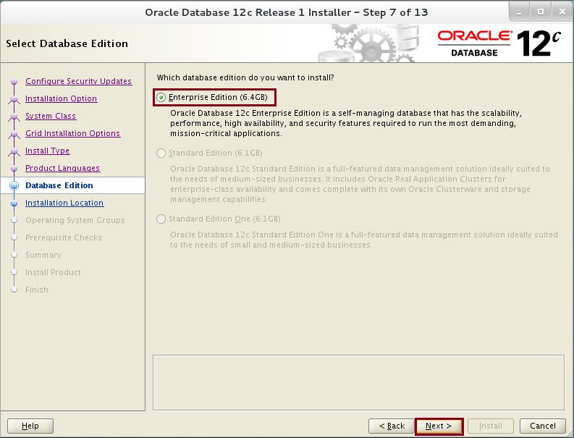

**Step 10:** Change the software location and click on "**Next**" button.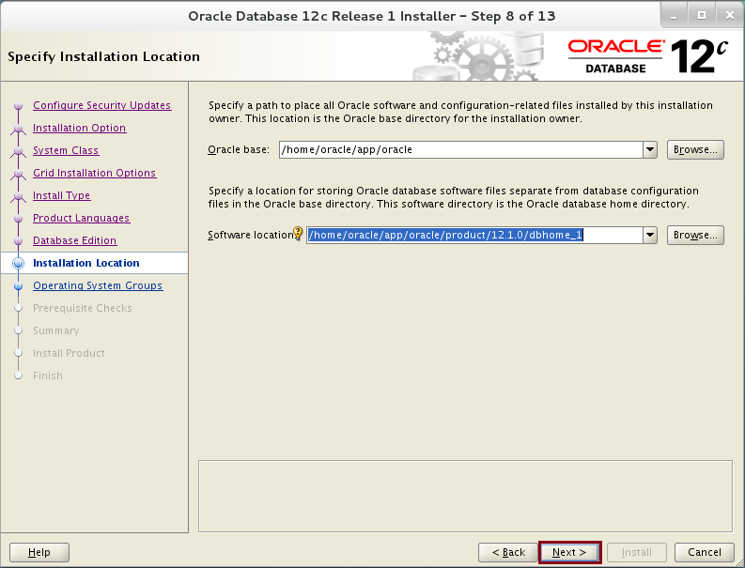

**Step 11:** Click on "**Next**" button.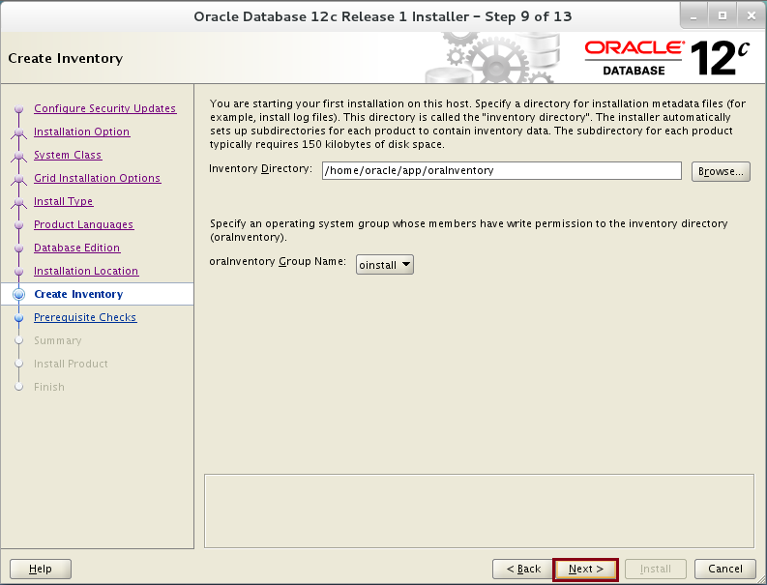

**Step 12:** Click on "**Next**" button.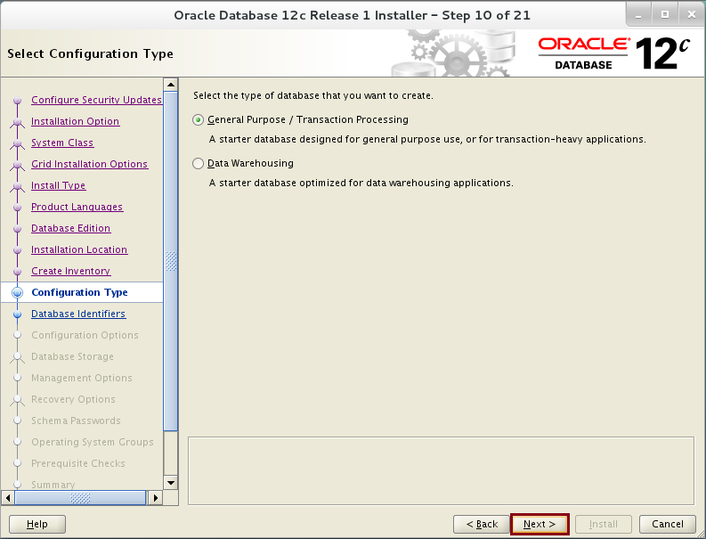

**Step 13:** Rename the Global database name to be "**DB12c.localdomain**". Uncheck "**Create as Container database**" option. Click on "**Next**" button.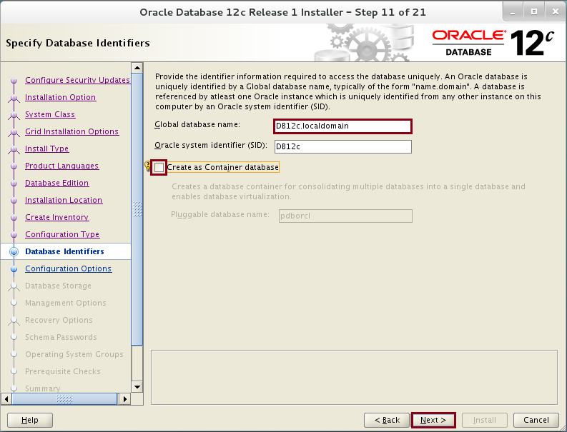

**Step 14:** Set the memory and select "**Character sets**" tab page.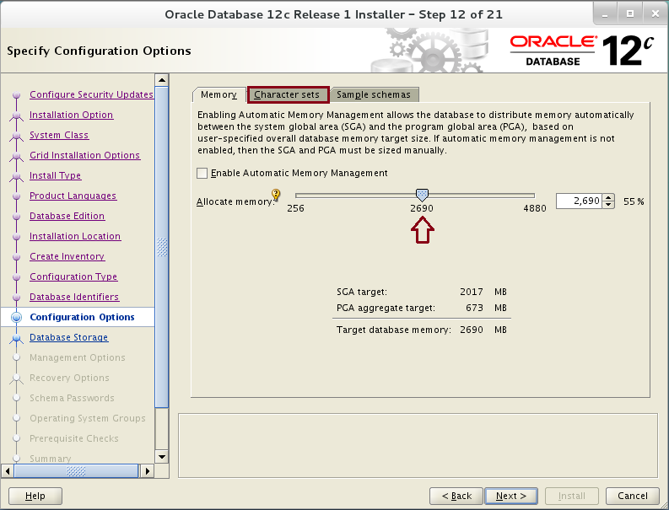

**Step 15:** Select "**Unicode (AL32UTF8)"** character set. Click on "**Sample Schemas**" tab page. 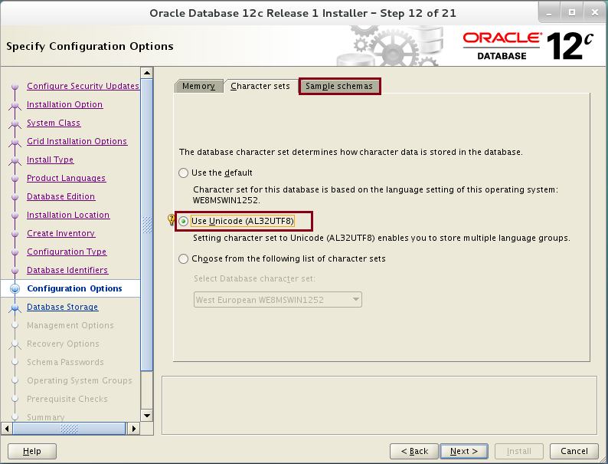

**Step 16:** Check "**Create database with sample schemas"** option. Click on "**Next**" button. 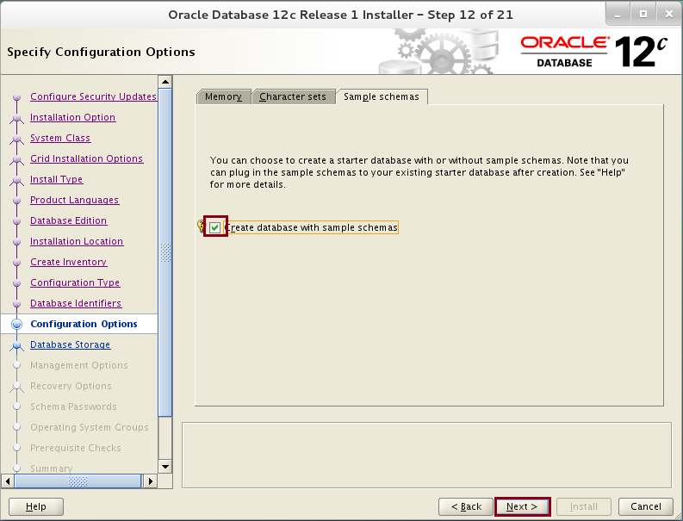

**Step 17:** Click on "**Next**" button.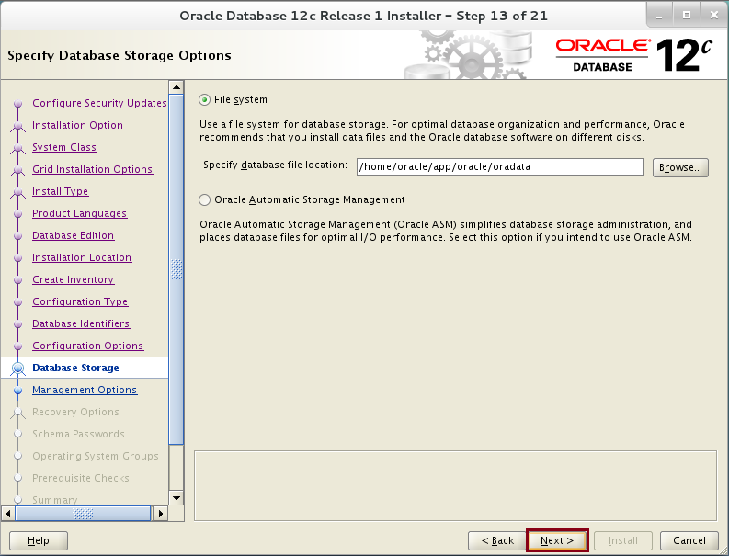

**Step 18:** Click on "**Next**" button. 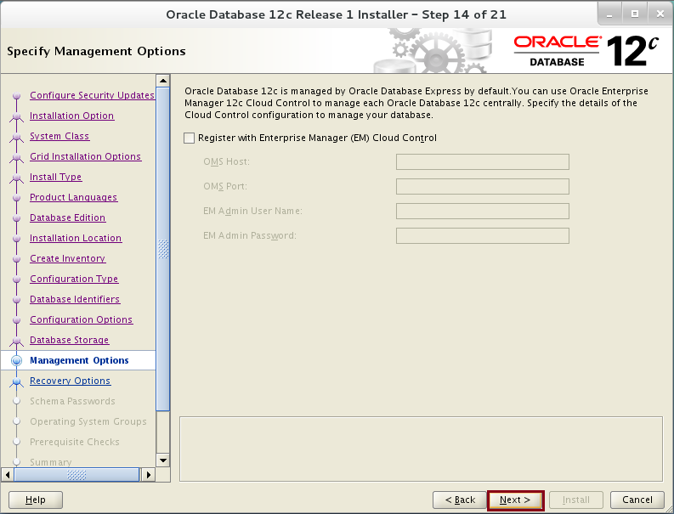

**Step 19:** Click on "**Next**" button.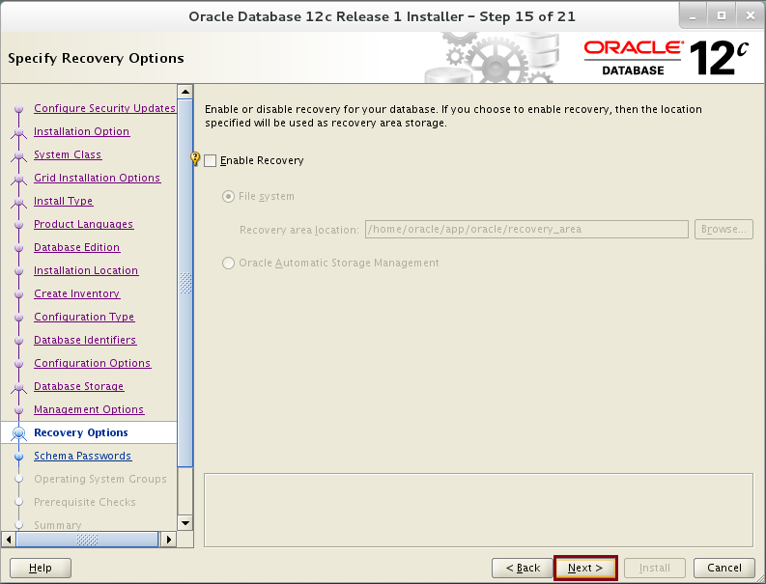

**Step 20:** Use the same password "**oracle**" for all account. Click on "**Next**" button and confirm. 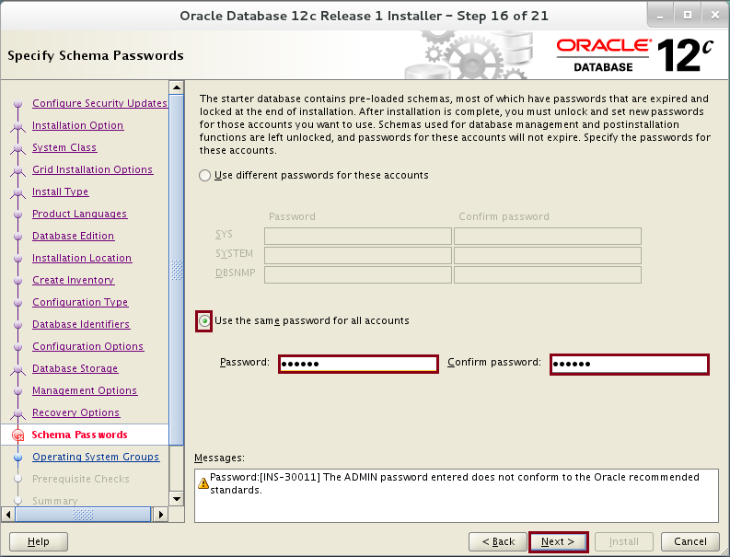

**Step 21:** Set "**dba**" group as Database Operator group. Click on "**Next**" button.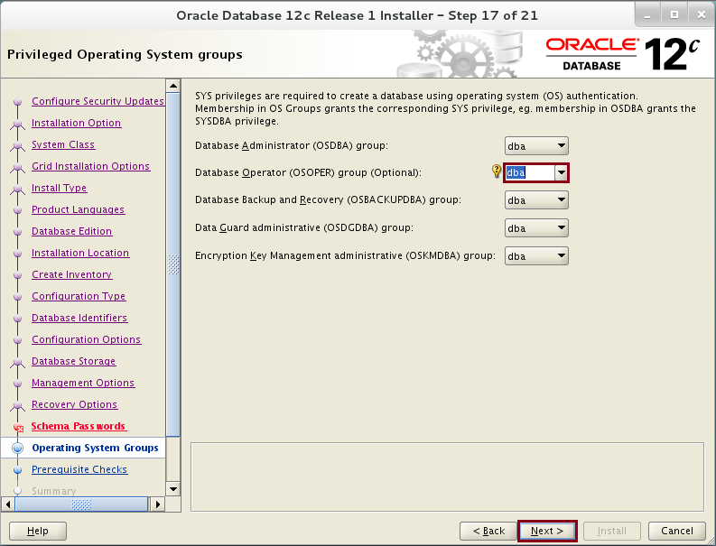

**Step 22:** If you still have missing packages notification, click on "**Fix & Check Again**" button. 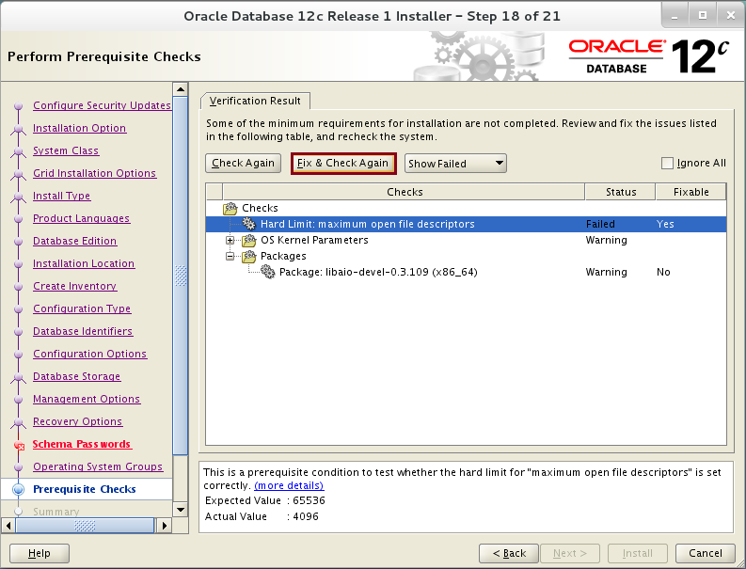

**Step 23:** Execute the script. 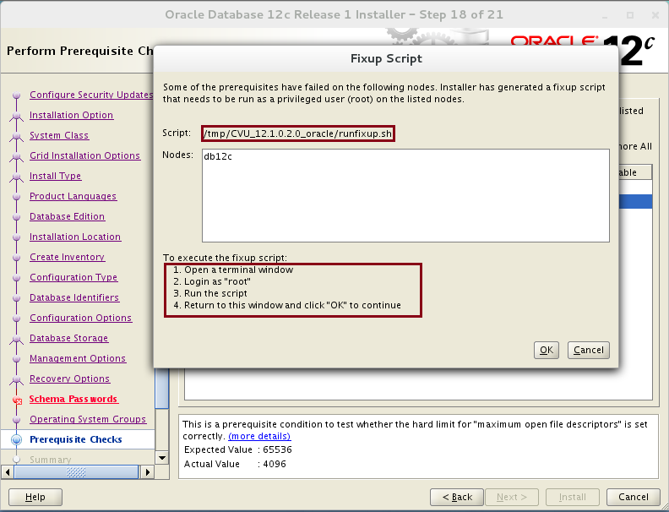

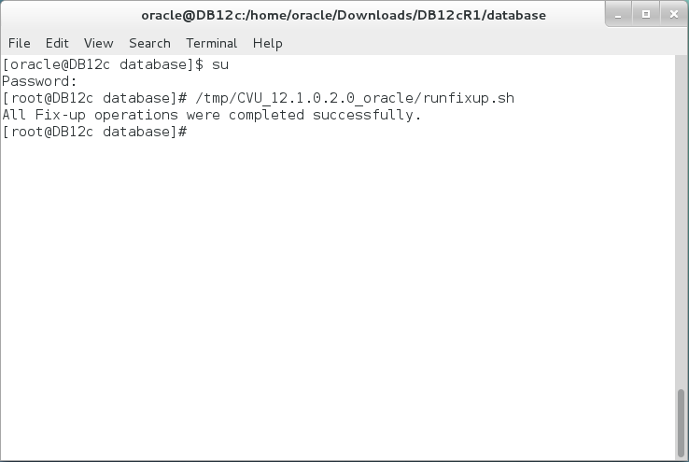

**Step 24:** The script fixed problems. Click on "**Verification Result**" tab page.

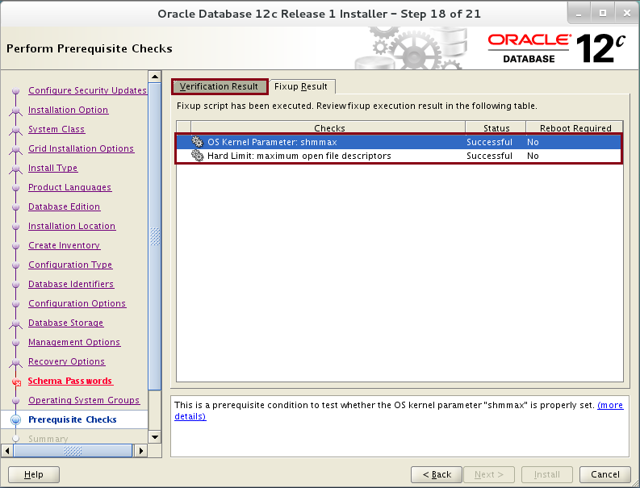

**Step 25:** Click on "**Check Again**" button. 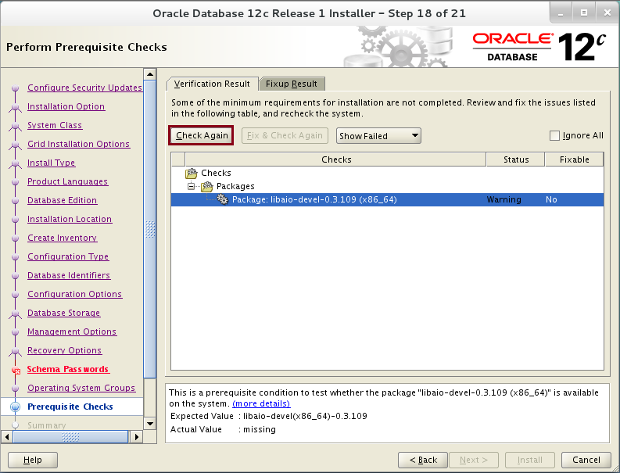

**Step 26:** Click on "**Install**" button.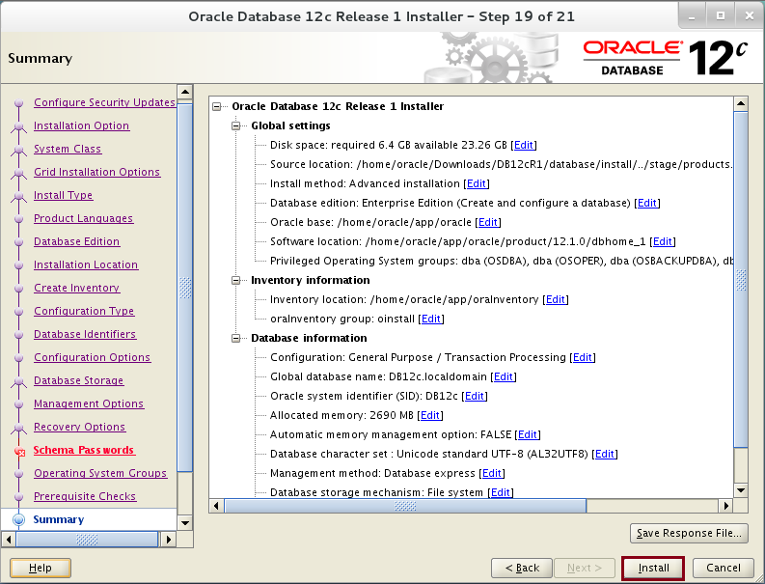

**Step 27:** Follow the instructions and execute the scripts. 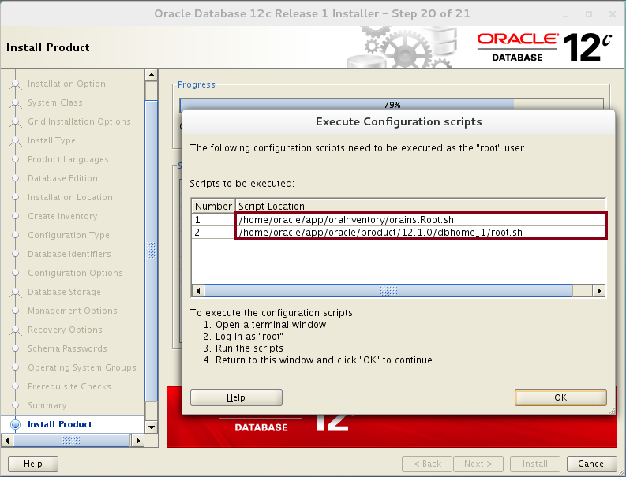

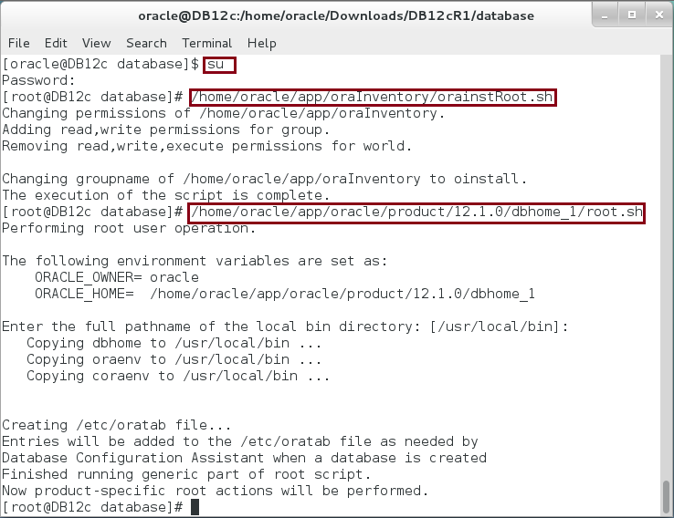

**Step 28:** Copy the EM Database Express URL "**https://DB12c.localdomain:5500/em**" for later use and click on "**OK**" to finish database installation and configuration. 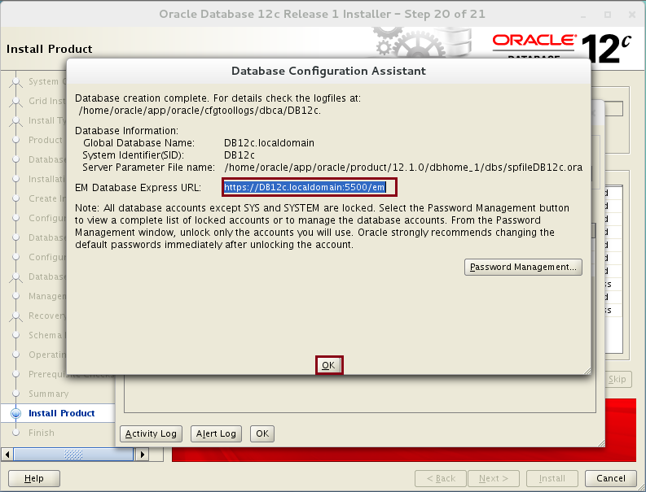

**Step 29:** Click on "**Close**" to end the wizard. 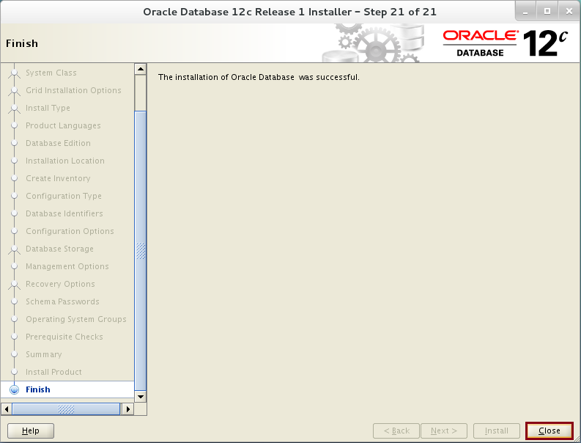

**Step 30:** Open the internet browser and enter URL "**https://DB12c.localdomain:5500/em**". Add security exception if necessary. 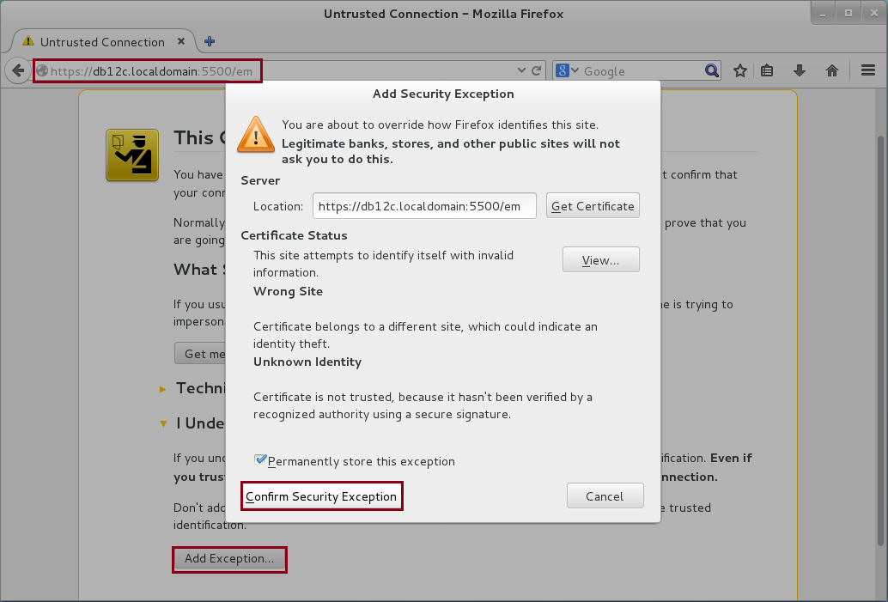

**Step 31:** Login as "**sys**"/ "**oracle**" with "**SYSDBA**" role. Click on "**Login**" button.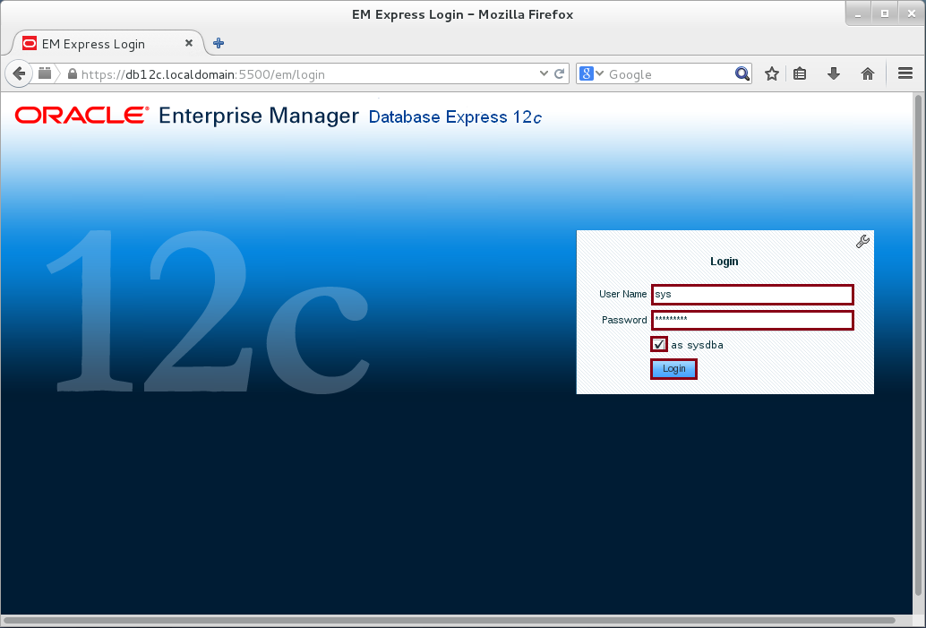

**Step 32:** The installation completed successfully.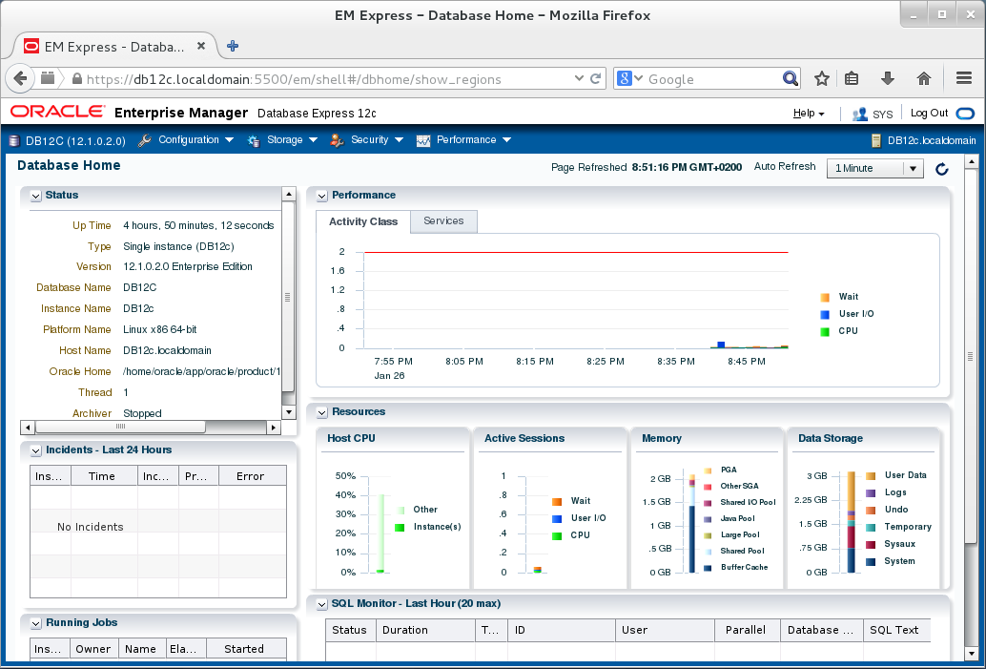

# SUMMARY

PL/SQL is a procedural language extension of SQL. Business logic and control can't be done with SQL alone. Application developers have two options to build the business logic: (1) using external programming language, such as Java or C#, and (2) using PL/SQL language. In comparison, PL/SQL has many advantages over any other external languages. For example, PL/SQL eliminates much of network overhead caused by sending SQL statements from the application server to Oracle Database. Instead, PL/SQL block is sent once over network and the whole block is processed then inside PL/SQL Engine which is integrated and running in Oracle Database. Another advantage of using PL/SQL is the code centrality. No matter how many applications call the system, the business logic is guaranteed to run.

After completing this lab exercise, you should be able to install Oracle Database 12c.

# REFERENCES

* https://docs.oracle.com/database/121/LADBI/inst_task.htm#LADBI7726
* http://docs.oracle.com/cd/E28385_01/en/E28377/html/STA102_Planning_Install_Linux_Install.6.6.htm
* https://docs.oracle.com/database/121/LTDQI/toc.htm

# INDEX

PL/SQL 2, 3, 44

SQL 2, 3, 44